**REMOTE REPORT EXECUTION**

**(Sakai Report Tool)**

INSTALLATION MANUAL

By: Sergio Muriel

Date: April, 2015

MAHARISHI UNIVERSITY OF MANAGEMENT

COMPUTER SCIENCE DEPARTMENT

2015

**Description**

Remote Report is an application that allows faculty to obtain reports of their courses in their email addresses based on the information that is already in Sakai system. In this application many technologies work together, namely:

* JSP: Homepage of this application.
* JQuery / Ajax web service request: To access Sakai Current User and Membership RESTful web services.
* Axis Web Service: This is to connect the home page with a SOAP web service that brings the entire list of courses.
* XMLRPC: Since the homepage is located in a Linux server and the Excel macro has to be executed in a Windows server, it is necessary to do an RPC call from the Linux server to the Windows server to execute the macro.
* Batch file: This file specifies the process that coordinates the calls to the Excel Macro, the compression of the generated PDF files and the mail sending.
* Excel Macro: Is the macro that generates every report.

**Installation Steps**

**Step 1**

Locate the CATALINA_HOME of your Sakai installation, and then copy the file

***sakai-axis\RemoteReportCourses.jws*** in:

CATALINA_HOME\webapps\sakai-axis\

To verify that the web service is working properly access:

http://*SERVER_WITH_SAKAI:PORT*/sakai-axis/RemoteReportCourses.jws

You should see something like this:

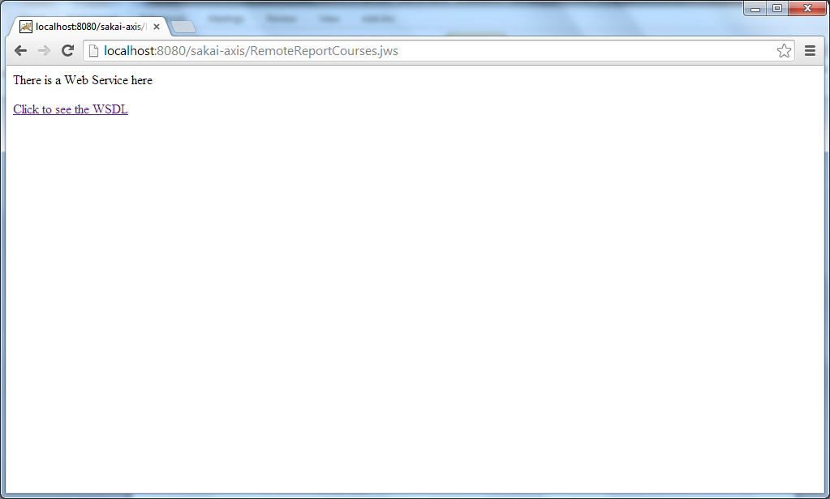

Then click to see the WSDL and you should see an XML page. Note that it is not necessary to restart Tomcat since Axis JWS files do hot-deployment (as JSP pages).

**Step 2**

In the same CATALINA_HOME of the previous step create the directory:

CATALINA_HOME\webapps\mum-tools\

And copy all the content of the ***mum-tools*** directory:

* mum-tools\remote-report-exec-multi.jsp
* mum-tools\remote-report-multi.jsp
* mum-tools\WEB-INF\lib\SakaiCoursesConsumer.jar
* mum-tools\WEB-INF\lib\axis.jar
* mum-tools\WEB-INF\lib\axis-ant.jar
* mum-tools\WEB-INF\lib\commons-codec-1.9.jar
* mum-tools\WEB-INF\lib\commons-discovery-0.2.jar
* mum-tools\WEB-INF\lib\commons-logging-1.0.4.jar
* mum-tools\WEB-INF\lib\jaxrpc.jar
* mum-tools\WEB-INF\lib\log4j.properties
* mum-tools\WEB-INF\lib\log4j-1.2.8.jar
* mum-tools\WEB-INF\lib\saaj.jar
* mum-tools\WEB-INF\lib\wsdl4j-1.5.1.jar
* mum-tools\WEB-INF\lib\xmlrpc-2.0-beta.jar

Go into ***SakaiCoursesConsumer.jar*** and edit:

***edu\mum\mscs\tools\remotereport\RemoteReportCourses.properties***

Set the ***rrQNAME*** value to the URL of the web service specified in the previous step.

Then, set the ***loginQNAME*** value to this URL:

http://*SERVER_WITH_SAKAI:PORT*/sakai-axis/SakaiLogin.jws

Set **usr/pwd** properties with **any** valid Sakai account. It is recommended this account have as less privileges as possible.

If you want to see the code, you can find it in: **SakaiCoursesConsumer\src**

You can also generate your own client for the web services mentioned (axis 1.4).

Restart Tomcat.

**Step 3**

In a Windows server, create the directory:

c:\sakaitools\

Assign permissions of reading, writing and execution to this folder to ***Everyone*** and copy the next files into:

* ***sakaitools/AutoReportsMultiple.bat***
* ***sakaitools/Sakai-courseReport.xlsm***
* ***sakaitools/XMLRPCRemoteReport/startRPCserver.bat***
* ***sakaitools/XMLRPCRemoteReport/edu/mum/mscs/tools/remotereport/xmlrpc/JavaServer.class***
* ***sakaitools/XMLRPCRemoteReport/lib/commons-codec-1.9.jar***
* ***sakaitools/XMLRPCRemoteReport/lib/xmlrpc-2.0-beta.jar***

Into this folder, create the folder:

c:\sakaitools\archive

**Step 4**

Go to ***c:\sakaitools\XMLRPCRemoteReport*** directory and execute:

***startRPCserver.bat***

You should see something like this:

Attempting to start XML-RPC Server for Remote Report Application.......

Started successfully.

Accepting requests. (Halt program to stop.)

By default, it is configured to use the port 1234. If there is any other service running on this port, then edit the batch file ***startRPCserver.bat*** and choose another one. In case you do that, you also need to change this port in the method ‘doRPC’ in:

**mum-tools\remote-report-exec-multi.jsp**

and check the specified server is correct.

Make sure this service always run. It should be in the “Startup” programs group.

**Step 5**

Install 7zip in directory ***c:\tools\ (c:\tools\7z.exe)*** and create this directory: ***c:\tools\sakai\logs\.*** Make sure Excel and PowerShell are working properly on this machine, and that you are able to run an Excel macro.

Install the MySQL ODBC connector:

* ***connector\mysql-connector-odbc-5.2.6-win32.msi***

Setup a MySQL ODBC data source using the previous connector:

* On Windows 7, run: ***C:\Windows\SysWOW64\odbcad32.exe***
* Create new System DSN with driver "MySQL ODBC 5.x Unicode Driver"
* Data Source Name: Sakai.cs (Excel macro looks for this)
* IP: (Sakai server IP or ask your DBA/network administrator)
* User: (Sakai DB user or ask your DBA/network administrator)
* Password: (Sakai DB password or ask your DBA/network administrator)
* Database: sakai

You should be able to see something like this:

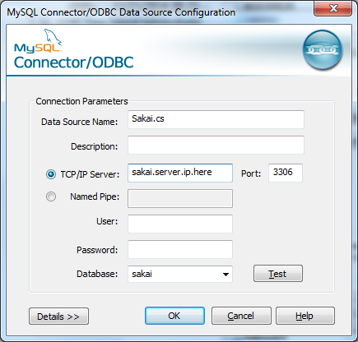 **Step 6**

Test MySQL Connector/ODBC Data Source.

Then test **AutoReportsMultiple.bat** in this way:

C:\sakaitools>AutoReportsMultiple.bat your_mail@some_server.com COURSE-SITE-12345 COURSE-SITE-67890

Put as many courses as you want and you know are valid Sakai site names, but take into account that the first parameter has to be your mail. If you have any spaces in the course name, you must replace them with slash ‘/’. You should get an email with all the reports specified.

**Step 7**

Finally, check that ***remote-report-multi.jsp*** page compiles and works properly. You should see something like this:

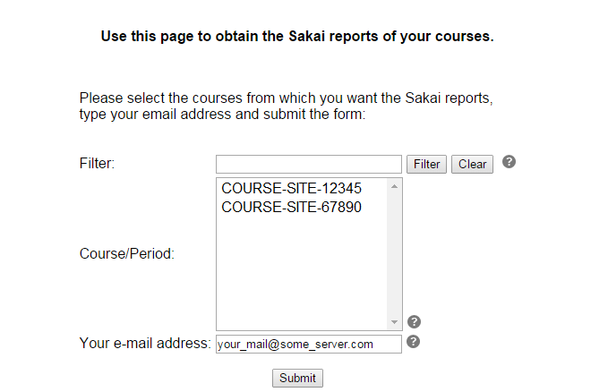

You can always embed this code in your own web pages as long as these pages link to each other in the code:

For **remote-report-multi.jsp:**

<form name="rrForm" method="post" action="remote-report-exec-multi.jsp" onsubmit="return validateForm();">

For **remote-report-exec-multi.jsp**:

response.sendRedirect("remote-report-multi.jsp");